

**Course Title:** CSE110

**Section:** 06

**Semester:** Summer 22

**Week 01 Class Practice**

**SUBMITTED TO**

Md Ashraf Uddin, PhD (Australia)

Associate Professor

***SUBMITTED BY***

**Name:** B M Shahria Alam

**Student ID:** 2021-3-60-016

**Date of submission:** 19 June 2022.

1.

import java.util.Scanner;

public class ComputerAreaWithConsoleInput {

public static void main(String[] args) {

Scanner input=new Scanner (System.in);

System.out.println("Enter a number for radius:");

double radius= input.nextDouble();

double area=radius*radius*3.1416;

System.out.println("Enter a number for radius "+radius+" is "+area);

}

}

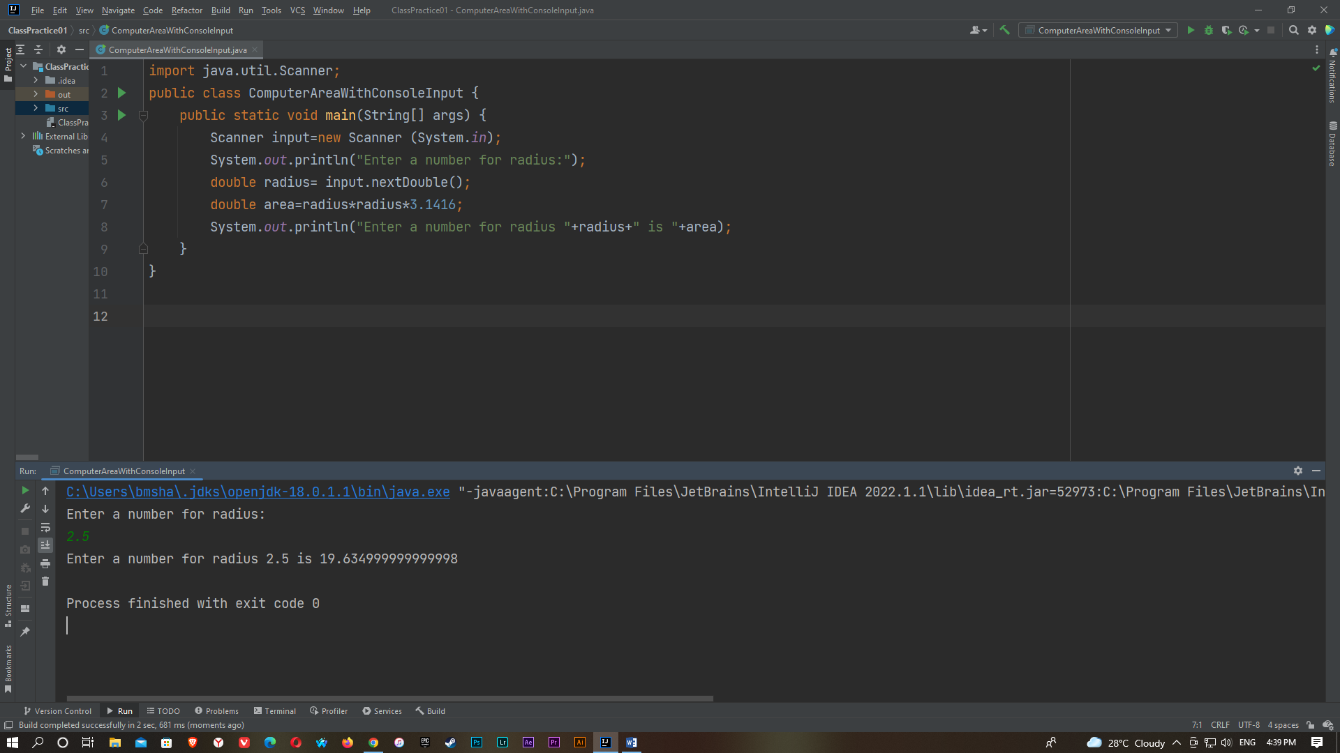

2.

import java.util.Scanner;

public class ComputerLoan {

public static void main(String[] args) {

Scanner input = new Scanner(System.in);

System.out.println("Enter annual interest rate, e.g. 7.25%: ");

double AnnualInterestRate = input.nextDouble();

double MonthlyInterestRate=AnnualInterestRate/1200;

System.out.println("Enter number of years, e.g. 5: ");

int numberofyears= input.nextInt();

System.out.println("Enter annual interest rate, e.g. 120000.95: ");

double LoanAmount = input.nextDouble();

double monthlypayment= LoanAmount*MonthlyInterestRate/(1-1/Math.pow(1+MonthlyInterestRate,numberofyears*12));

double totalpayment=monthlypayment*numberofyears*12;

System.out.println("The monthly payment is $ "+(monthlypayment*100)/100.0);

System.out.println("The total payment is $ "+(totalpayment*100)/100.0);

}

}

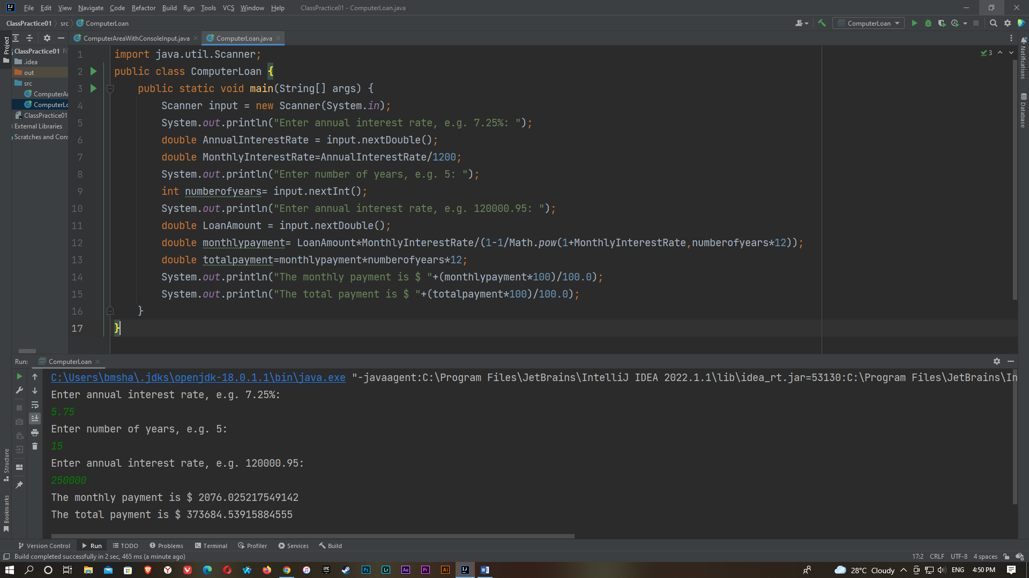

3.

import java.util.Scanner;

public class ComputerAndInterpretBMI {

public static void main(String[] args) {

Scanner input = new Scanner(System.in);

System.out.println("Enter weight in pounds: ");

double weight = input.nextDouble();

System.out.println("Enter height in meter: ");

double height = input.nextDouble();

final double KILOGRAMS_PER_POUND= 0.45359237;

final double METERS_PER_INCH= 0.0254;

double weightInkilograms= weight*KILOGRAMS_PER_POUND;

double heightInMeters= height*METERS_PER_INCH;

double bmi=weightInkilograms/(heightInMeters*heightInMeters);

System.out.println("BMI is "+bmi);

if(bmi<18.5)

System.out.println("Underweight");

else if(bmi<25)

System.out.println("Normal");

else if(bmi<30)

System.out.println("Ovweweight");

else

System.out.println("Obese");

}

}

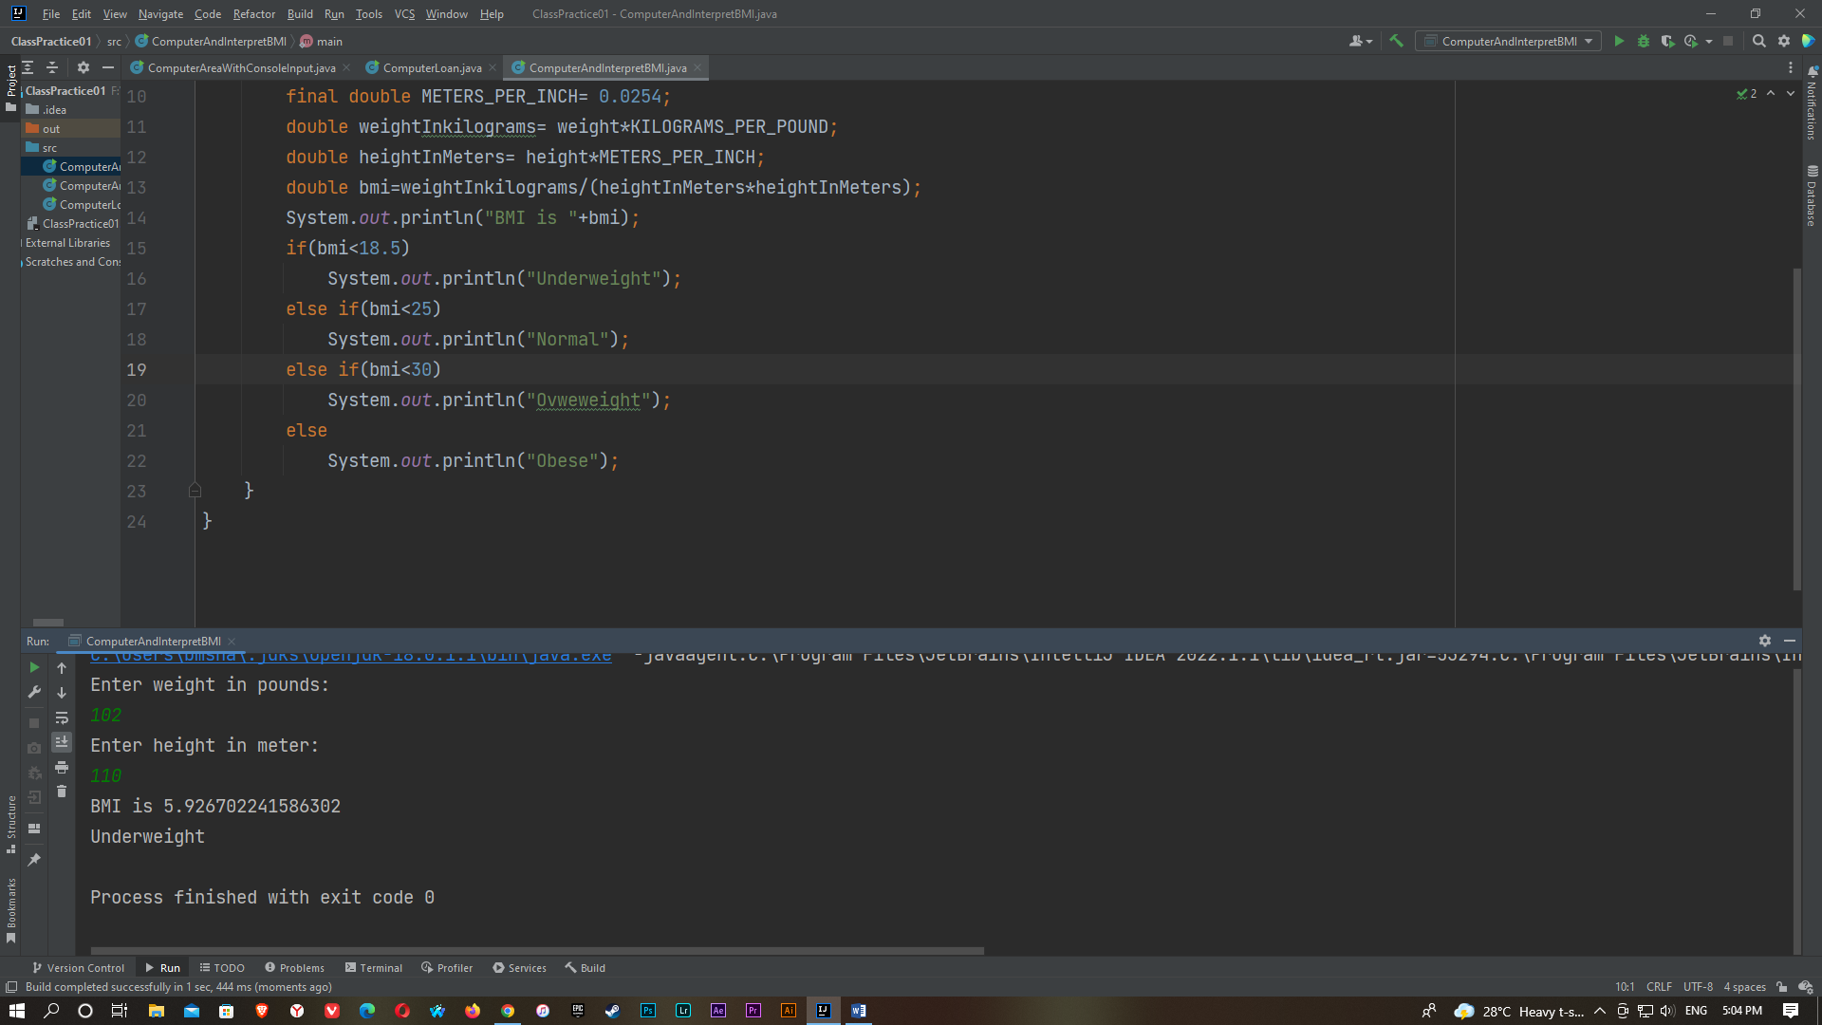

4.

import java.util.Scanner;

public class ComputeTax {

public static void main(String[] args) {

Scanner input = new Scanner(System.in);

System.out.println("(0-single filer, 1-married jointly or "+"qualifying widow(er), 2-married separately, 3-head of "+"household) Enter the filing status: ");

int status = input.nextInt();

System.out.println("Enter the taxable income: ");

double income= input.nextDouble();

double tax=0;

if(status==0)

{

if(income <= 8350)

tax=income*0.10;

else if(income<=33950)

tax=8350*0.10+(income-8350)*0.15;

else if(income<=82250)

tax=8350*0.10+(33950-8350)*0.15+(income-33950)*0.25;

else if(income<=171550)

tax=8350*0.10+(33950-8350)*0.15+(82250-33950)*0.25+(income-82250)*0.28;

else if(income<=372950)

tax=8350*0.10+(33950-8350)*0.15+(82250-33950)*0.25+(171550-82250)*0.28+(income-171550)*0.33;

else

tax=8350*0.10+(33950-8350)*0.15+(82250-33950)*0.25+(171550-82250)*0.28+(372950-171550)*0.33+(income-372950)*0.35;

}

else if(status==1)

{

if(income <= 16700)

tax=income*0.10;

else if(income<=67900)

tax=16700*0.10+(income-16700)*0.15;

else if(income<=137050)

tax=16700*0.10+(67901-16700)*0.15+(income-67900)*0.25;

else if(income<=208850)

tax=16700*0.10+(67901-16700)*0.15+(137050-33950)*0.25+(income-137050)*0.28;

else if(income<=372950)

tax=16700*0.10+(67901-16700)*0.15+(137050-33950)*0.25+(208850-137050)*0.28+(income-208850)*0.33;

else

tax=16700*0.10+(67901-16700)*0.15+(137050-33950)*0.25+(208850-137050)*0.28+(372951-171550)*0.33+(income-372951)*0.35;

}

else if(status==2)

{

if (income <= 8350)

tax = income * 0.10;

else if (income <= 33950)

tax = 8350 * 0.10 + (income - 8350) * 0.15;

else if (income <= 68525)

tax = 8350 * 0.10 + (33950 - 8350) * 0.15 + (income - 33950) * 0.25;

else if (income <= 104425)

tax = 8350 * 0.10 + (33950 - 8350) * 0.15 + (68525 - 33950) * 0.25 + (income - 68525) * 0.28;

else if (income <= 186475)

tax = 8350 * 0.10 + (33950 - 8350) * 0.15 + (68525 - 33950) * 0.25 + (104425 - 68525) * 0.28 + (income - 104425) * 0.33;

else

tax = 8350 * 0.10 + (33950 - 8350) * 0.15 + (68525 - 33950) * 0.25 + (104425 - 68525) * 0.28 + (186475 - 104425) * 0.33 + (income - 186475) * 0.35;

}

else if(status==3)

{

if (income <= 11950)

tax = income * 0.10;

else if (income <= 45500)

tax = 11950 * 0.10 + (income - 11950) * 0.15;

else if (income <= 117450)

tax = 11950 * 0.10 + (45500 - 11950) * 0.15 + (income - 45500) * 0.25;

else if (income <= 190200)

tax = 11950 * 0.10 + (45500 - 11950) * 0.15 + (117450 - 45500) * 0.25 + (income - 117450) * 0.28;

else if (income <= 372950)

tax = 11950 * 0.10 + (45500 - 11950) * 0.15 + (117450 - 45500) * 0.25 + (190200- 117450) * 0.28 + (income - 190200) * 0.33;

else

tax = 11950 * 0.10 + (45500 - 11950) * 0.15 + (117450 - 45500) * 0.25 + (190200 - 117450) * 0.28 + (372950 - 1190200) * 0.33 + (income - 372950) * 0.35;

}

else

{

System.out.println("Error: invalid status");

System.exit(1);

}

System.out.println("Tax is "+(tax*100)/100.0 );

}

}

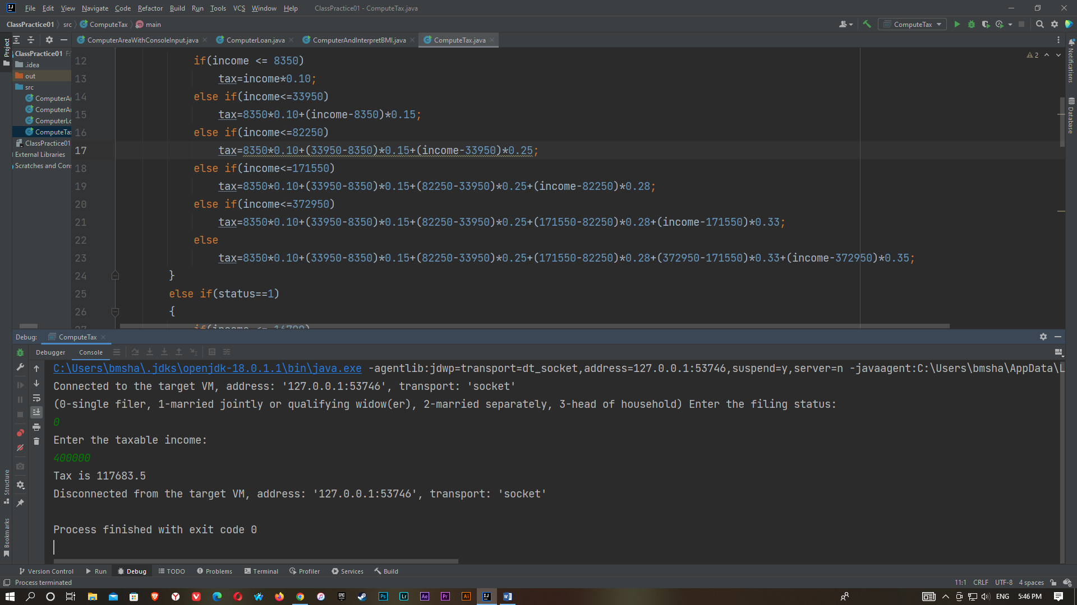

5.

import java.util.Scanner;

public class ChaineseZodiac {

public static void main(String[] args) {

Scanner input = new Scanner(System.in);

System.out.println("Enter a year: ");

int year = input.nextInt();

switch(year%12)

{

case 0: System.out.println("monkey");break;

case 1: System.out.println("rooster");break;

case 2: System.out.println("dog");break;

case 3: System.out.println("pig");break;

case 4: System.out.println("rat");break;

case 5: System.out.println("ox");break;

case 6: System.out.println("tiger");break;

case 7: System.out.println("rabbit");break;

case 8: System.out.println("dragon");break;

case 9: System.out.println("snake");break;

case 10: System.out.println("horse");break;

case 11: System.out.println("sheep");break;

}

}

}

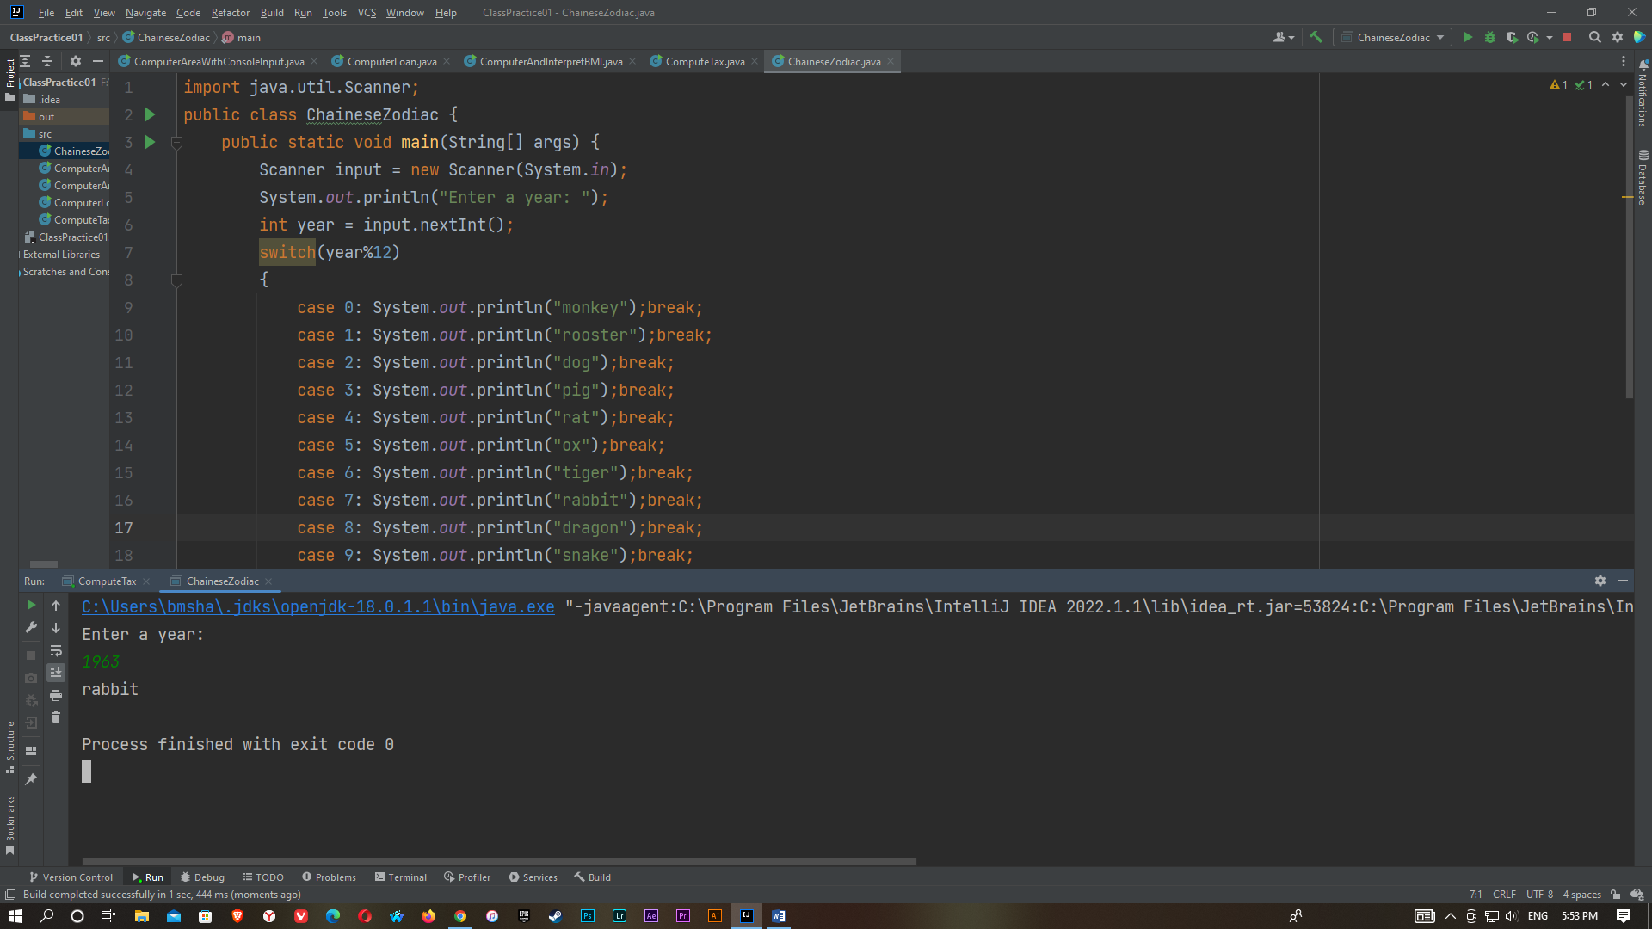

6)

import java.util.Scanner;

public class ComputeAngles {

public static void main(String[] args) {

Scanner input = new Scanner(System.in);

System.out.println("Enter three points: ");

double x1 = input.nextDouble();

double y1 = input.nextDouble();

double x2 = input.nextDouble();

double y2 = input.nextDouble();

double x3 = input.nextDouble();

double y3 = input.nextDouble();

double a=Math.sqrt((x2-x3)*(x2-x3)+(y2-y3)*(y2-y3));

double b=Math.sqrt((x1-x3)*(x1-x3)+(y1-y3)*(y1-y3));

double c=Math.sqrt((x1-x2)*(x1-x2)+(y1-y2)*(y1-y2));

double A=Math.toDegrees(Math.acos((a*a-b*b-c*c)/(-2*b*c)));

double B=Math.toDegrees(Math.acos((b*b-a*a-c*c)/(-2*a*c)));

double C=Math.toDegrees(Math.acos((c*c-b*b-a*a)/(-2*b*a)));

System.out.println("The three angles are "+Math.round(A*100)/100.0+" "+ Math.round(B*100)/100.0+" "+Math.round(c*100)/100.0);

}

}

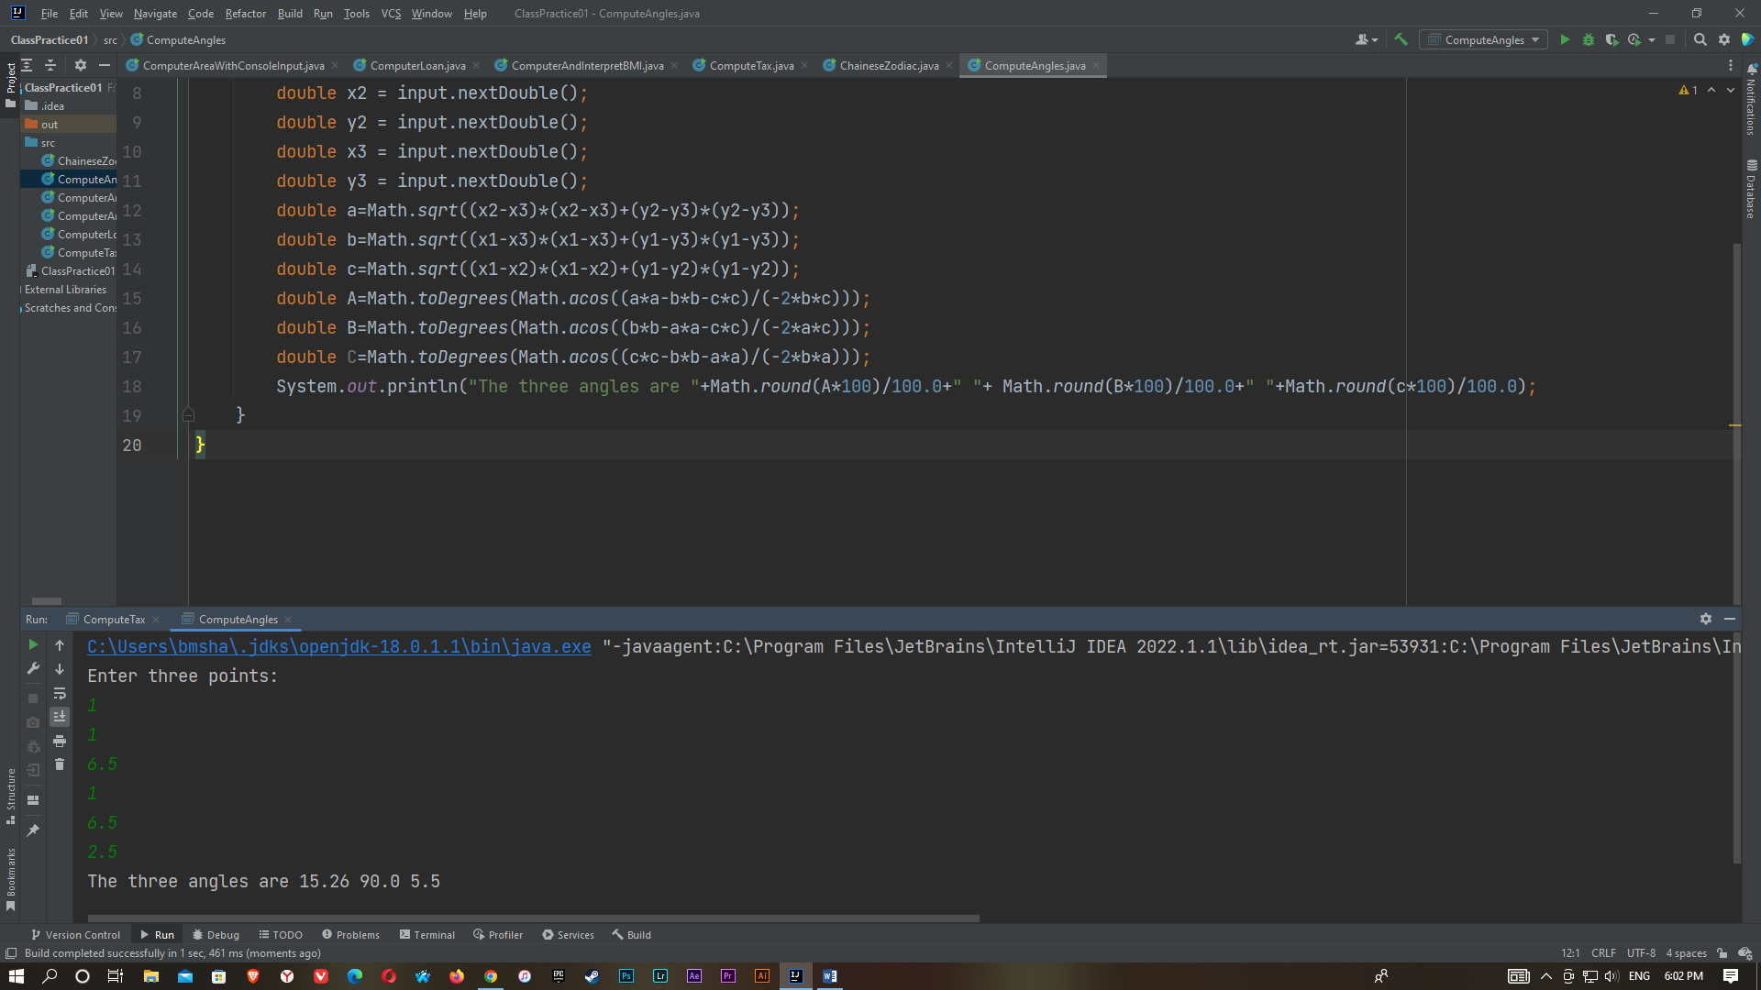

7)

import java.util.Scanner;

public class LotteryUsingString {

public static void main(String[] args) {

Scanner input = new Scanner(System.in);

String lottery = "" + (int) (Math.random() * 10) + (int) (Math.random() * 10);

System.out.println("Enter your lottary pick (two digits): ");

String guess = input.nextLine();

char lottarydigit1= lottery.charAt(0);

char lottarydigit2= lottery.charAt(1);

char guessdigit1= guess.charAt(0);

char guessdigit2= guess.charAt(1);

System.out.println("The lottary number is : " +lottery);

if(guess.equals(lottery))

System.out.println("Exact match: you win $10,000");

else if(guessdigit2== lottarydigit1 && guessdigit1==lottarydigit2)

System.out.println("Match all digits: you win $3,000");

else if(guessdigit1 ==lottarydigit1 ||guessdigit1 ==lottarydigit2 || guessdigit2==lottarydigit1 || guessdigit2== lottarydigit2)

System.out.println("Match one digits: you win $1,000");

else

System.out.println("Sorry, no match.");

}

}

